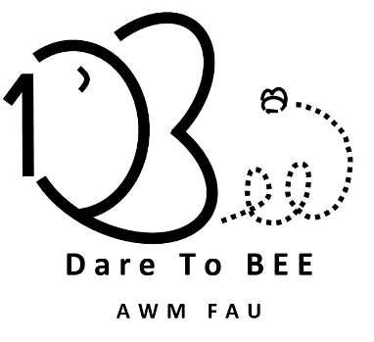

Greetings!

It is that time again for a lovely Tea-Time session from your local AWM FAU Student Chapter.  On October 27th from 4-5pm, this tea session will focus our attention on Intellectual Property and we will show a pre-recorded 50-min webinar provided by the [FAU's Division of Research](http://fau.edu/research/).

***We kindly request that you please*** [***RSVP***](https://docs.google.com/forms/d/e/1FAIpQLScvy4sCkPnenAnzHXmyKumU6vssXJ4bpk2kqsbJlfT1QCA11Q/viewform) ***to this October session and do share this email with your friends and colleagues!***

--

Catherine Berrouet

*FAU AWM Chapter President*

Tran Ngo

*Vice President*

Archana Timsina

*Secretary*

Dr. Yuan Wang

*Faculty Advisor*

[*http://www.math.fau.edu/awm/index.php*](http://www.math.fau.edu/awm/index.php)

[AWM FAU Instagram](https://www.instagram.com/awmd2bee/)

Dare to BEE (Be Exceptionally Encouraged)